TYRE LINK

11 AUSTRAL PLACE HALLAM VICTORIA 3803 | PH 03) 8795 7100 FAX 03) 8795 7781



PRODUCT CATALOGUE 2016

 

C:\Users\Megabus\Pictures\THUNDERER

**EFFECTIVE JANUARY 2016**

** PTY. LTD**

**ABN 28 161 824 942**

**11 AUSTRAL PLACE**

**HALLAM VICTORIA 3803**

**AUSTRALIA**

**PH. 03 8795 7100 – FAX. 03 8795 7781**

[**sales@tyre-link.com.au**](mailto:sales@tyre-link.com.au)

** **

 C:\Users\Megabus\Pictures\THUNDERER

**CONTENTS**

P5 - PASSENGER PERFORMANCE - 35, 40 SERIES

P6 - PASSENGER - 45, 50 SERIES

P7 - PASSENGER - 55 SERIES

P8 - PASSENGER - 60, 65 SERIES

P9 - PASSENGER - 70, 75, 80 SERIES

P10 - WHEELS

P11 - TYRE TECHNICAL INFORMATION

P13 - SUV AND 4WD - 60, 65 SERIES

P14 - SUV AND 4WD - 70 SERIES

P15 - SUV AND 4WD - 75, 80 SERIES

P16 - 4WD

P17 - 4WD

P19/20 - COMMERCIAL LIGHT TRUCK

P22/23 - TRUCK AND BUS

P25/26 - FORKLIFT, INDUSTRIAL, AGRICULTURAL



**PASSENGER RANGE**

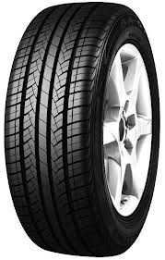**SA07**

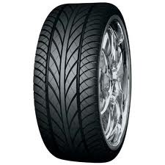**SV308**



**PASSENGER RANGE**

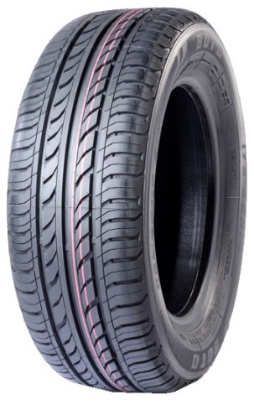 WINDA WP15 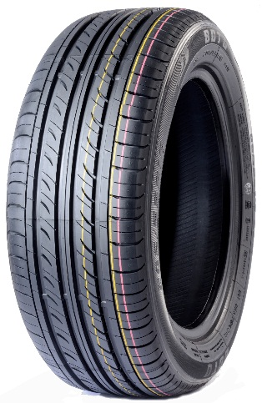WINDA WP16

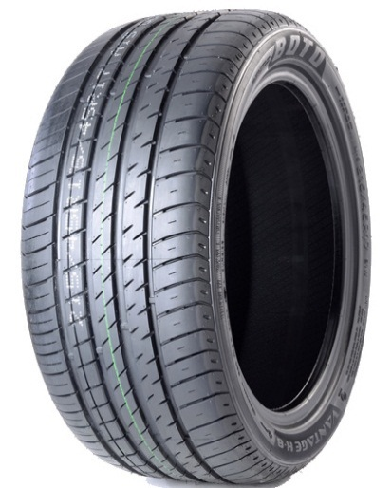WINDA WH16

**35 SERIES PATTERN LOAD/SPEED**

|  |  |  |
| --- | --- | --- |
| 215/35R18 | WH16 WINDA | 84W |
| 235/35R19 | SA07 TRAZANO | 91W |
| 225/35R20 | SPORT | 93W |
| 245/35R19 | SA07 TRAZANO | 93W |
| 255/35R19 | SA07 TRAZANO | 96W |
| 245/35R20 | WH16 WINDA | 95W |
| 245/35R20 | SA07 TRAZANO | 95W |

**40 SERIES PATTERN LOAD/SPEED**

|  |  |  |
| --- | --- | --- |
| 205/40R17 | WH16 WINDA | 84W |
| 215/40R17 | WH16 WINDA | 87W |
| 215/40R17 | SV308 (D) TRAZANO | 87W |
| 245/40R17 | SA07 TRAZANO | 95W |
| 225/40R18 | WH16 WINDA | 92W |
| 225/40R18 | SA07 TRAZANO | 92W |
| 235/40R18 | WH16 WINDA | 95W |
| 235/40R18 | SA07 TRAZANO | 95W |
| 245/40R18 | SA07 TRAZANO | 97Y |
| 245/40R18 | WH16 WINDA | 97W |
| 245/40R19 | SA07 TRAZANO | 94Y |
| 275/40R20 | SU318 TRAZANO | 106V |

**45 SERIES PATTERN LOAD/SPEED**

|  |  |  |
| --- | --- | --- |
| 205/45R16 | SA05 (A) TRAZANO | 87W |
| 205/45R17 | SV308 (D) TRAZANO | 88W |
| 215/45R17 | WH16 WINDA | 91W |
| 215/45R17 | SA07 TRAZANO | 91W |
| 225/45R17 | WH16 WINDA | 91W |
| 225/45R17 | SA07 TRAZANO | 94W |
| 235/45R17 | SA07 TRAZANO | 97W |
| 235/45R17 | WH16 WINDA | 97W |
| 245/45R17 | SA07 TRAZANO | 95Y |
| 255/45R17 | SA07 TRAZANO | 98W |
| 215/45R18 | SA07 TRAZANO | 89W |
| 225/45R18 | WH16 WINDA | 95W |
| 225/45R18 | SA07 TRAZANO | 95W |
| 235/45R18 | SA07 TRAZANO | 94Y |
| 245/45R18 | SA07 TRAZANO | 96Y |
| 245/45R18 | WH16 WINDA | 100W |
| 245/45R20 | N8000 | 103Y |
| 275/45R20 | WV11 WINDA | 110 V |

**50 SERIES PATTERN LOAD/SPEED**

|  |  |  |
| --- | --- | --- |
| 195/50R15 | WH16 WINDA | 82V |
| 195/50R16 | WH16 WINDA | 88V |
| 205/50R16 | WH16 WINDA | 87V |
| 225/50R16 | SA05 (A) TRAZANO | 92W |
| 205/50R17 | WH16 WINDA | 93W |
| 205/50R17 | SA07 TRAZANO | 89W |
| 215/50R17 | SA07 TRAZANO | 91W |
| 225/50R17 | WH16 WINDA | 98W |
| 225/50R17 | SA07 TRAZANO | 94W |
| 235/50R17 | WH16 WINDA | 96W |
| 235/50R18 | SA07 TRAZANO | 101W |
| 245/50R18 | SA07 TRAZANO | 100Y |
| 245/50R20 |  | 102V |
| 265/50R20 | SA07 TRAZANO | 111V |

**55 SERIES PATTERN LOAD/SPEED**

|  |  |  |
| --- | --- | --- |
| 185/55R15 | WH16 WINDA | 82V |
| 185/55R15 | SAO5 (A) TRAZANO | 82V |
| 195/55R15 | WH16 WINDA | 85V |
| 195/55R15 | SV308 TRAZANO | 85V |
| 205/55R15 | H660 TRAZANO | 88V |
| 185/55R16 | RP26 TRAZANO | 83V |
| 195/55R16 | RP26 TRAZANO | 91V |
| 205/55R16 | WP16 WINDA | 91W |
| 205/55R16 | SA07 TRAZANO | 91V |
| 215/55R16 | WH16 WINDA | 97W |
| 215/55R16 | SA07 TRAZANO | 93V |
| 225/55R16 | WH16 WINDA | 95W |
| 225/55R16 | SA07 TRAZANO | 95W |
| 215/55R17 | WH16 WINDA | 98W |
| 215/55R17 | SA07 TRAZANO | 94V |
| 225/55R17 | WH16 WINDA | 101W |
| 225/55R17 | SA07 TRAZANO | 97W |
| 235/55R17 | WH16 WINDA | 99W |
| 235/55R17 | SV308 TRAZANO | 103W |
| 235/55R18 | SU318 TRAZANO | 100V |
| 255/55R18 | SU318 TRAZANO | 109V |
| 245/55R19 | AZ850 | 103V |

**60 SERIES PATTERN LOAD/SPEED**

|  |  |  |
| --- | --- | --- |
| 175/60R14 | RP26 TRAZANO | 79H |
| 185/60R14 | WP15 WINDA | 82T |
| 195/60R14 | WP16 WINDA | 86H |
| 175/60R15 | ZE914 | 81H |
| 185/60R15 | WP16 WINDA | 84H |
| 195/60R15 | WP16 WINDA | 88V |
| 205/60R15 | WP16 WINDA | 91H |
| 215/60R15 | WP16 WINDA | 94H |
| 195/60R16 | RP18 | 89H |
| 205/60R16 | WP16 WINDA | 96H |
| 215/60R16 | WP16 WINDA | 99H |
| 225/60R16 | WP16 WINDA | 98V |
| 235/60R16 | WP16 WINDA | 100H |
| 235/60R16 | H550A TRAZANO | 100H |
| 215/60R17 | SU317 TRAZANO | 96H |
| 225/60R17 | WP16 WINDA | 99H |
| 235/60R18 | WV11 WINDA | 107H |
| 265/60R18 | SU318 TRAZANO | 114V |

**65 SERIES PATTERN LOAD/SPEED**

|  |  |  |
| --- | --- | --- |
| 155/65R13 | WP15 WINDA | 73T |
| 165/65R13 | WP15 WINDA | 77T |
| 165/65R14 | WP15 WINDA | 79H |
| 175/65R14 | WP15 WINDA | 82H |
| 175/65R14 | H550 TRAZANO | 82H |
| 175/65R15 | RP26 TRAZANO | 84H |
| 185/65R14 | WP15 WINDA | 86H |
| 185/65R14 | H550A TRAZANO | 86H |
| 195/65R14 |  | 89H |
| 215/65R14 |  | 96H |
| 185/65R15 | WP16 WINDA | 88H |
| 195/65R15 | WP16 WINDA | 95H |
| 195/65R15 | RP26 TRAZANO | 91H |
| 205/65R15 | WP16 WINDA | 94H |
| 205/65R15 | H550A TRAZANO | 94H |
| 215/65R15 | WP16 WINDA | 96H |
| 205/65R16 | WP16 WINDA | 95H |
| 215/65R16 | WP16 WINDA | 98H |
| 215/65R16 | H550 TRAZANO | 98H |
| 225/65R16 | H550 TRAZANO | 100H |

**70 SERIES PATTERN LOAD/SPEED**

|  |  |  |
| --- | --- | --- |
| 155/70R13 | WP15 WINDA | 75T |
| 155/70R13 | H550A TRAZANO | 75T |
| 165/70R13 | H550A TRAZANO | 79T |
| 165/70R13 | WP15 WINDA | 79T |
| 175/70R13 | WP15 WINDA | 82H |
| 175/70R13 | SW601 TRAZANO | 82T |
| 185/70R13 | WP15 WINDA | 86T |
| 165/70R14 | WP15 WINDA | 85T |
| 175/70R14 | WP15 WINDA | 84T |
| 175/70R14 | H550A TRAZANO | 84T |
| 185/70R14 | WP15 WINDA | 88T |
| 195/70R14 | WP15 WINDA | 91T |
| 205/70R14 | WP15 WINDA | 93T |
| 205/70R14 | H550A TRAZANO | 95T |
| 205/70R15 | WP16 WINDA | 96T |
| 205/70R15 | H550A TRAZANO | 96H |
| 215/70R15 | WP16 WINDA | 98T |
| 215/70R15 | H550A TRAZANO | 98H |
| 215/70R15 | SW608 SNOW | 98H |

**75 SERIES PATTERN LOAD/SPEED**

|  |  |  |
| --- | --- | --- |
| 185/75R14 |  | 89T |

**80 SERIES PATTERN LOAD/SPEED**

|  |  |  |
| --- | --- | --- |
| 155/80R13 | H550A TRAZANO | 79T |

**WHEELS SIZE FITMENT**

|  |  |  |  |
| --- | --- | --- | --- |
| WHEEL* | 10 X 4 | MULTI FIT | WHITE |
| WHEEL | 13 X 4.5 5/108 | HOLDEN - 0 OFFSET | WHITE |
| WHEEL | 13 X 4.5 5/114.3 | FORD - 0 OFFSET | WHITE |
| WHEEL* | 13 X 4.5 5/114.3 | FORD - 0 OFFSET | GALVANISED |
| WHEEL* | 14 X 6 5/108 HT | HOLDEN - +14 | GALVANISED |
| WHEEL | 14 X 6 5/120.65 HQ | HOLDEN - +12 | WHITE |
| WHEEL* | 14 X 6 5/120.65 HQ | HOLDEN +14 | BLACK |
| WHEEL* | 14 X 6 5/120.65 HQ | HOLDEN - +14 | GALVANISED |
| WHEEL | 14 X 6 5/114.3 | FORD - +12 | WHITE |
| WHEEL | 14 X6 5/114.3 | FORD - +12 | BLACK |
| WHEEL | 14 X 6 5/114.3 | FORD | GALVANISED |
| WHEEL* | 14 X 6 6/139.7 | TOYOTA L/C +14 | WHITE |
| WHEEL* | 14 X 6 6/139.7 | TOYOTA L/C +14 | BLACK |
| WHEEL* | 14 X 6 6/139.7 | TOYOTA L/C +14 | GALVANISED |
| WHEEL | 15 X 6 6/139.7 | * 0 | WHITE |
| WHEEL* | 15 X6 5/114.3 | FORD - 0 | WHITE |
| WHEEL* | 15 X 6 5/114.3 | FORD - 0 | BLACK |
| WHEEL | 15 X 7 6/139.7 | * -5 | WHITE |
| WHEEL | 15 X 7 6/139.7 | * +10 | BLACK |
| WHEEL | 15 X 8 5/114.3 | * 0 | BLACK |
| WHEEL | 15 X 8 6/139.7 | * -19 | WHITE |
| WHEEL | 15 X 8 6/139.7 | * -19 | BLACK |
| WHEEL | 16 X 7 6/139.7 | * -11 | WHITE |
| WHEEL | 16 X 7 6/139.7 | * -11 | BLACK |
| WHEEL | 16 X 8 6/139.7 | * -13 | WHITE |
| WHEEL | 16 X 8 6/139.7 | * -13 | BLACK |
| WHEEL | 16 X 8 6/139.7 | * +20 | WHITE |
| WHEEL | 16 X 8 6/139.7 | * +20 | BLACK |

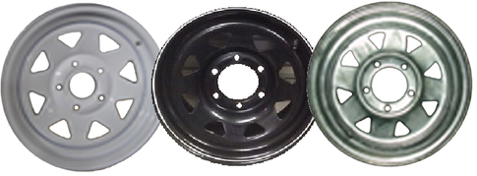

Plus sizing of tyres and wheels was originally designed to enhance performance but has become more of an appearance upgrade than a performance upgrade. Though appearance is now the primary factor in plus sizing, there is an increase in performance due to two key factors. First, as a result of the plus sizing conversion, the tyre footprint is wider and provides a larger contact patch with the driving surface. Secondly, the lower aspect ratio causes a shorter sidewall and quicker steering response. The improved lateral stability and increased steering response improves overall performance of the vehicle.

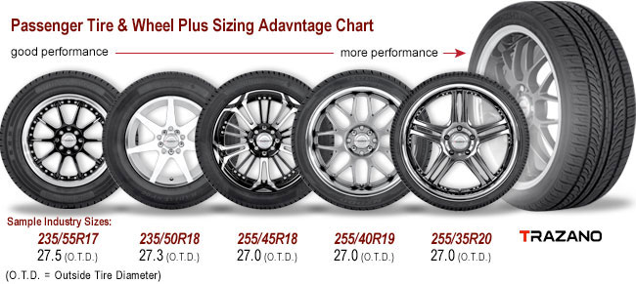

The size of most passenger and light truck tyres is represented by a combination of letters and numbers that can be found on the tyre sidewall. The photograph below shows an example of a 205/60R16 92H passenger tyre.

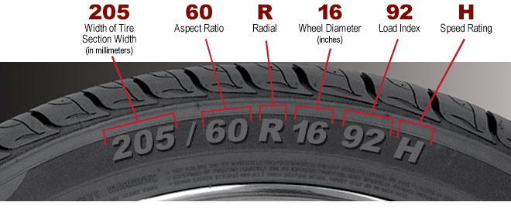

**SUV AND 4WD RANGE**

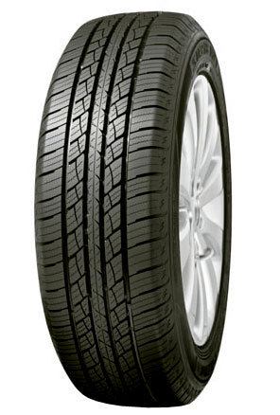 **SU318 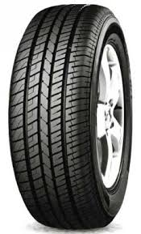SU317**

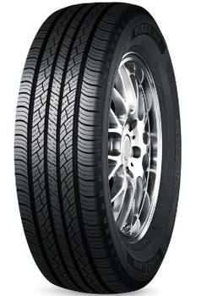 **WV11 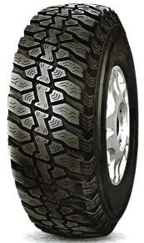 CR857**

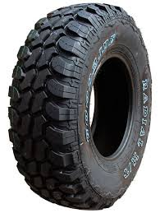 **SL366 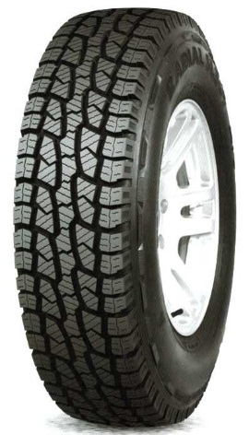 SL369**

**60 SERIES PATTERN LOAD/SPEED**

|  |  |  |
| --- | --- | --- |
| 215/60R17 | SU318 TRAZANO | 96H |
| 235/60R17 | SU318 TRAZANO` | 102T |
| 265/60R17 | SU318 TRAZANO | 102T |
| 235/60R18 | SU318 TRAZANO | 103V |
| 265/60R18 | SU318 TRAZANO | 114V |

**65 SERIES PATTERN LOAD/SPEED**

|  |  |  |
| --- | --- | --- |
| 215/65R16 | SU317 TRAZANO | 98H |
| 255/65R16 | SU318 TRAZANO | 109H |
| 225/65R17 | SU317 TRAZANO | 102H |
| 235/65R17 | WV11 WINDA | 104H |
| 235/65R17 | SU317 TRAZANO | 104H |
| 235/65R17 | SL369 TRAZANO | 104H |
| 245/65R17 | WV11 WINDA | 107H |
| 245/65R17 | SU317 TRAZANO | 107S |
| 245/65R17 | SL369 TRAZANO | 107S |
| 255/65R17 | A607 | 110H |
| 265/65R17 | WV11 WINDA | 112H |
| 265/65R17 | SU318 TRAZANO | 112T |
| 265/65R17 | SL369 TRAZANO | 112S |
| 275/65R17 | SU318 TRAZANO | 115T |
| 275/65R18 | SL369 TRAZANO | (10) 123/120Q |

**70 SERIES PATTERN LOAD/SPEED**

|  |  |  |
| --- | --- | --- |
| 265/70R15 |  | 112H |
| 215/70R16 | SU317 TRAZANO | 100H |
| 225/70R16 | WV11 WINDA | 103H |
| 225/70R16 | SU317 TRAZANO | 103H |
| 235/70R16 | WV11 WINDA | 106H |
| 235/70R16 | SU317 TRAZANO | 106H |
| 235/70R16 | SL369 TRAZANO | 106S |
| 245/70R16 | WV11 WINDA | 107H |
| 245/70R16 | SU317 TRAZANO | 107T |
| 245/70R16 | SL369 TRAZANO | (10) 115Q |
| 255/70R16 | WV11 WINDA | 111H |
| 265/70R16 | WV11 WINDA | 112H |
| 265/70R16 | SU317 TRAZANO | 112H |
| 265/70R16 | SL369 TRAZANO | 118Q |
| 275/70R16 | SU318 TRAZANO | 114H |
| 245/70R17 | SL369 TRAZANO | (10) 119/116Q |
| 265/70R17 | SL369 TRAZANO | (10) 121/118Q |
| 265/70R17 | SL386 | (10) 121/118Q |
| 285/70R17 | SL369 TRAZANO | (10) 121/118Q |
| 315/70R17 | SL386 | (10) 121/118Q |

**75 SERIES PATTERN LOAD/SPEED**

|  |  |  |
| --- | --- | --- |
| 215/75R15 | WV11 WINDA | 100T |
| 215/75R15 | WA80+ WINDA | 100S |
| 225/75R15 | WV11 WINDA | 102T |
| 235/75R15 | WA80+ WINDA | 104/101Q |
| 235/75R15 | WV11 WINDA | 105T |
| 235/75R15 | SL369 TRAZANO | (6) 104/101Q |
| 235/75R15 | SL369 TRAZANO | (8) 110/107Q |
| 235/75R15 | SL366 TRAZANO | (8) 110/107Q |
| 235/75R15 | CR857 TRAZANO | (6) 104/101Q |
| 215/75R16 | WR01 WINDA | 116Q |
| 225/75R16 | WA80+ WINDA | 115/112Q |
| 225/75R16 | SL369 TRAZANO | (10) 115/112Q |
| 245/75R16 | WA80+ WINDA | 120/116Q |
| 245/75R16 | SL369 TRAZANO | (10) 120/116Q |
| 245/75R16 | SL366 TRAZANO | (10) 120/116Q |
| 245/75R16 | CR857+ TRAZANO | (10) 120/116Q |
| 265/75R16 | WA80+ WINDA | (10) 123/120Q |
| 265/75R16 | SL369 TRAZANO | (10) 123/120Q |
| 265/75R16 | SL366 TRAZANO | (10) 123/120Q |
| 265/75R16 | SL386 | (10) 123/120Q |
| 265/75R16 | CR857 TRAZANO | (10) 123/120Q |
| 285/75R16 | WA80+ WINDA | (8) 122/119Q |
| 285/75R16 | SL369 TRAZANO | (8) 122/119Q |
| 285/75R16 | SL386 TRAZANO | (10) 126/123Q |
| 315/75R16 | SL386 | (10) 127/124Q |

**80 SERIES PATTERN LOAD**

|  |  |  |
| --- | --- | --- |
| 205 R 16 | A929 | (8) 110/108S |
| 205/80R16 | SL369 TRAZANO | (6) 104S |
| 205/80R16 | SL369 TRAZANO | (8) 110/108S |

**85 SERIES PATTERN LOAD**

|  |  |  |
| --- | --- | --- |
| 235/85R16 | CR857+ TRAZANO | (10) 120/116Q |
| 235/85R16 | SL369 TRAZANO | (10) 120/116Q |
| 30x9.50R15 | SL366 TRAZANO | 104Q |
| 31x10.50R15 | WA8O+ WINDA | 109Q |
| 31x10.50R15 | SL369 TRAZANO | 109Q |
| 31x10.50R15 | SL366 TRAZANO | 109Q |
| 31x10.50R15 | SL386 TRAZANO | 109Q |
| 31x10.50R15 | CR857 TRAZANO | 109Q |
| 32x11.50R15 | SL366 TRAZANO | 113Q |
| 33x12.50R15 | SL386 TRAZANO | 108Q |
| 33x12.50R15 | MUD | 108Q |

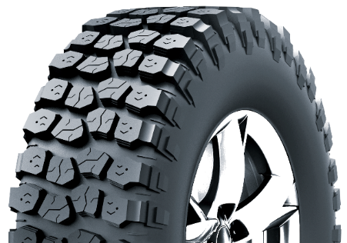 **SL386**

**THUNDERER TRAC GRIP R408 MUD**

**SERIES PATTERN LOAD**

|  |  |  |
| --- | --- | --- |
| 30X9.50R15 | R408 THUNDERER | 104Q |
| 31X10.50R15 | R408 THUNDERER | 109Q |
| 33X12.50R15 | R408 THUNDERER | 108Q |
| 35X12.50R17 | R408 THUNDERER | 121Q* |
| 33X12.50R18 | R408 THUNDERER | 118Q* |
| 35X12.50R18 | R408 THUNDERER | 123Q* |
| 33X12.50R20 | R408 THUNDERER | 114Q* |
| 35X12.50R20 | R408 THUNDERER | 121Q* |
| 235/75R15 | R408 THUNDERER | 104/101Q |
| 245/75R16 | R408 THUNDERER | 120/116Q |
| 245/75R17 | R408 THUNDERER | 121/118Q |
| 265/75R16 | R408 THUNDERER | 123/120Q |
| 285/75R16 | R408 THUNDERER | 126/123Q* |
| 285/70R17 | R408 THUNDERER | 121/118Q* |
| 295/70R17 | R408 THUNDERER | 121/118Q* |

**(* DENOTES 3 PLY SIDEWALL)**

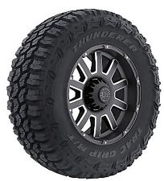**R408**

**TRAZANO, WINDA, CHAO YANG LT RANGE**

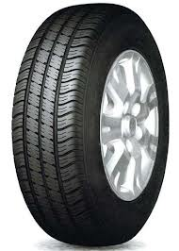 SC301 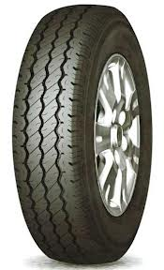 SL305

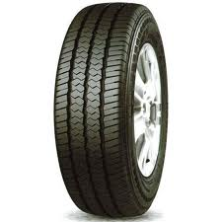SC328 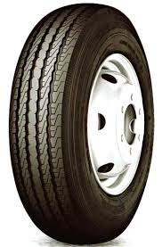ST303

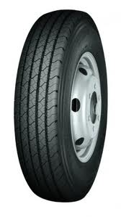CR869 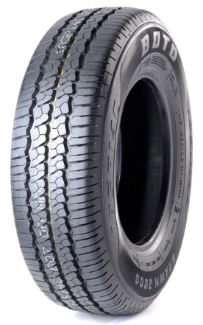WINDA WL15

**COMMERCIAL LTR PATTERN LOAD/SPEED**

|  |  |  |
| --- | --- | --- |
| 600 x 9 SET | (6) TT HWY |  |
| 500 x 10 SET | (8) TT CR823 HWY |  |
| 500 R 12 | (8) TL CR868 HWY |  |
| 155R12C | (8) TL SL305 | 88/86Q |
| 155R13C | SL305 | 90/88S |
| 165R13C | SL305 | 94/92Q |
| 175R13C | SL305 | 97/95Q |
| 165R14C |  | 97/95Q |
| 175R14C |  | 99/98Q |
| 185R14C | WL15 | 102/100S |
| 195R14C | WL15 | 106/104S |
| 195R14C | SC301 | 106/104Q |
| 185R15 | WR01 | 103/102T |
| 195R15C | WR01 | 106/104S |
| 195R15C | SC328 | 106/104R |
| 205R14C | WR01 | 109/107R |
| 205R14C | SC301 | 109/107Q |
| 205/65R15C | SC301 | 102/100T |
| 195/65R16C | SC328 | 104/102T |
| 205/65R16C | SC328 | 107/105R |
| 215/65R16C | SC328 | 109/107R |
| 225/65R16C | SC328 | 112/110R |
| 235/65R16C | SC328 | 115/113R |
| 215/60R16C | SC301 | 108/106T |
| 195/70R15C | WR01 | 104R |
| 205/70R15C | WR01 | 106R |
| 215/70R15C | SC301 | 104/102S |
| 215/70R15C | SC328 | 109/107R |
| 225/70R15C | SC328 | 112/110R |
| 215/70R16C | CP521 | 108/106 |
| 185/75R16C | SL309 |  |
| 195/75R16C | WR01 | 107/105R |
| 195/75R16C | SC328 | 107/105R |
| 205/75R16C | H170 | 110/108Q |
| 215/75R16C | WR01 | 116Q |
| 225/75R15C | STZC | (10) TRAILER |
| 195/85R16C | ST313 | (12) 108/107N |
| 215/85R16C | CM938 | (10) 120/118 |
| 235/85R16 | CR960A | (14) 129/125L |

**COMMERCIAL LTR PATTERN LOAD/SPEED**

|  |  |  |
| --- | --- | --- |
| 700R15 SET | TT ST303 HWY | (10) |
| 650R16 SET | TT ST303 HWY | (10) |
| 650R16 | TL ST303 HWY | (12) |
| 700R16 SET | TT ST303 HWY | (12) |
| 700R16 SET | TT ST313 HWY | (12) |
| 700R16 | TL ST303 HWY | (12) |
| 700R16 | TL CM998 DRIVE | (14) |
| 750R16 SET | TT CR869 HWY | (14) |
| 750R16 SET | TT CB981 DRIVE | (14) |
| 750R16 SET | TT CB999 A/T | (14) |
| 825R15 SET | TT CM958 HWY | (18) |
| 825R16 SET | TT CR960A HWY | (14) |
| 825R16 SET | TT CB981 DRIVE | (14) |

 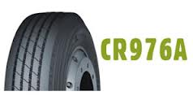

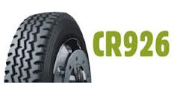 [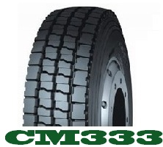](http://www.google.com.au/url?sa=i&rct=j&q=&esrc=s&source=images&cd=&cad=rja&uact=8&ved=0CAcQjRw&url=http://njnl.net/goods.php?id%3D158&ei=WBmTVbyQEJDX8gWbmKOgDw&bvm=bv.96783405,d.dGc&psig=AFQjCNFMnJD9Ku_hNcCFZEpL4afbsYyHPg&ust=1435790012604729)

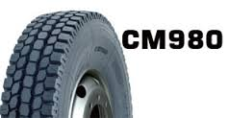 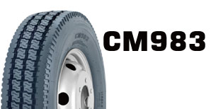

**TRUCK & BUS PATTERN LOAD/SPEED**

|  |  |  |
| --- | --- | --- |
| 750 X 17 SET | TT HWY | (14) |
| 8.5R17.5 | TL CR950 HWY | (12) 121/120L |
| 9.5R17.5 | TL CR950 HWY | (16) 143/141J |
| 9.5R17.5 | TL MD738 DRIVE | (16) 132/130L |
| 205/75R17.5 | TL CR960A HWY | (14) 124/122M |
| 205/75R17.5 | TL CM986 DRIVE | (14) 124/122M |
| 215/75R17.5 | TL CR960A HWY | (16) 135/133J |
| 215/75R17.5 | TL CM986 DRIVE | (16) 135/133J |
| 235/75R17.5 | TL CR960A HWY | (16) 143/141J |
| 235/75R17.5 | TL CM986 DRIVE | (16) 143/141J |
| 225/90R17.5 | TL HWY | (14) 127L |
| 225/70R19.5 | TL CR960A HWY | (12) 125/123M |
| 225/70R19.5 | TL CM986 DRIVE | (12) 125/123M |
| 245/70R19.5 | TL CR960A HWY | (16) 136/134M |
| 265/70R19.5 | TL CR976A HWY | (16) 140/138M |
| 285/70R19.5 | TL CR960A HWY | (16) 146/144M |
| 305/70R19.5 | TL MZ679 HWY | (18) 146/143L |
| 305/70R19.5 | TL HWY | (16) 148/145M |
| 305/70R19.5 | TL DRIVE | (16) 148/145M |
| 750 R 20 | TT CR926 A/P | (14) 130/128L |
| 825 X 20 | TT CR942 HWY | (14) |
| 825 X 20 | TT CL951 DRIVE | (14) |
| 825 R 20 SET | TT CR926 A/P | (14) 136/134K |
| 825 R 20 SET | TT CB981 DRIVE | (16) 139/137K |
| 900 X 20 SET | TT CR942 HWY | (14) |
| 900 X 20 SET | TT CR949 HWY | (16) 145/140G |
| 900 X 20 SET | TT CL928 DRIVE | (16) 145/140G |
| 900 R 20 SET | TT CR976A HWY | (16) 144/142K |
| 900 R 20 SET | TT CB981 DRIVE | (16) 144/142K |
| 900 R 20 SET | TT CR926 A/P | (16) 144/142K |
| 10.00x20 SET | TT CR948 HWY | (16) 146/142G |
| 10.00R20 SET | TT CM954 DRIVE | (16) 146/143K |
| 10.00R20 SET | TT CR944 HWY | (16) 146/143K |
| 10.00R20 SET | TT CB972 DRIVE | (16) 146/143K |
| 10.00 – 20 SET | TT CL626 EDT | (18) |
| 12.00 – 20 SET | TT CL626 EDT | (18) |
| 12.00R20 SET | TT (18) CR926 | (20) 154/151K |

**TRUCK & BUS PATTERN LOAD/SPEED**

|  |  |  |
| --- | --- | --- |
| 9 R22.5 | TL CR950 HWY | (14) 136/134M |
| 10R22.5 | TL CR950 HWY | (14) 141/139M |
| 10R22.5 | TL DRIVE | (14) |
| 11R22.5 | TL CR926D HWY | (16) 148/145M |
| 11R22.5 | TL CR960A HWY | (16) 148/145M |
| 11R22.5 | TL CR960E HWY | (16) 148/145J |
| 11R22.5 | TL AS678 HWY | (16) 148/145L |
| 11R22.5 | TL CB981 DRIVE | (16) 148/145L |
| 11R22.5 | TL CM980 DRIVE | (16) 148/145L |
| 11R22.5 | TL CM993 DRIVE | (16) 148/145L |
| 11R22.5 | TL CM333 DRIVE | (16) 148/145L |
| 11R22.5 | TL CB972 DRIVE | (16) 148/145J |
| 11R22.5 | TL MACH II HWY | (16) 148/14M |
| 11R22.5 | TL MACH IV DRIVE | (16) 148/145L |
| 13R22.5 | TL CM923 DRIVE | (18) 156/150K |
| 255/70R22.5 | TL CR976A HWY | (16) 140/137M |
| 275/70R22.5 | TL CR976A HWY | (16) 148/145M |
| 275/70R22.5 | TL MD738 DRIVE | (16) 148/145J |
| 295/80R22.5 | TL CR976A HWY | (18) 152/149M |
| 295/80R22.5 | TL CM958 HWY | (16) 150/147M |
| 315/80R22.5 | TL CR931 HWY | (18) 154/151M |
| 315/80R22.5 | TL CM993 DRIVE | (18) 154/151M |
| 385/65R22.5 | TL AT557 DRIVE | (20) 158/160K |
| 385/65R22.5 | TL CR931 HWY | (18) 158/160K |
| 425/65R22.5 | TL CR931 HWY | (20) 165K |
| 445/65R22.5 | TL CR931 HWY | (20) 169K |

 

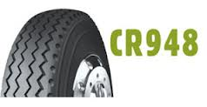 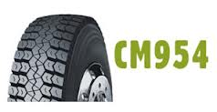

 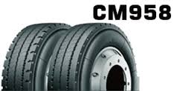

**FORK & INDUSTRIAL PATTERN LOAD/SPEED**

|  |  |  |
| --- | --- | --- |
| 10 – 16.5 | TL (8) K192 |  |
| 10 - 16.5 | TL (8) CL718 |  |
| 10 – 16.5 | TL (12) CL720 BRUTUS |  |
| 10 – 16.5 | TL (8) CL719 R/GRIP |  |
| 12 – 16.5 | TL (10) K192 |  |
| 12 - 16.5 | TL (10) CL718 |  |
| 12 – 16.5 | TL (14) CL721 |  |
| 11.00 x 20 SET | TT (18) CL946 | PNEUMATIC |
| 12.00 x 20 SET | TT (20) CL946 (S) | 156/151G |
| 12.00R20 SET | TT (18) CR926 | PNEUMATIC |
| 14.00 x 20 SET | TT (20) CL908 | PNEUMATIC |
| 500 x 8 SET | TT (10) CL619 | PNEUMATIC |
| 600 x 9 SET | TT (10) CL619 | PNEUMATIC |
| 650 x 10 SET | TT (10) CL619 | PNEUMATIC |
| 700 x 12 SET | TT (12) CL619 | PNEUMATIC |
| 250 X 15 SET | TT (16) CL619 | PNEUMATIC |
| 700 X 15 SET | TT (12) CL619 | PNEUMATIC |
| 750 X 15 SET | TT (12) CL619 | PNEUMATIC |
| 21X8X9 | CL 403S | SOLID |
| 28X9X15 SET | TT (14) CL619 | PNEUMATIC |
| 28 X 9X 15 | CL 403S | SOLID |
| 300 X 15 SET | TT CL619 | PNEUMATIC |
| 300 X 15 | CL403S | SOLID |
| 500 X 8 | CL 402S | SOLID |
| 600 X 9 | CL 402S | SOLID |
| 650 X 10 | CL 402S | SOLID |
| 700 X 12 | CL402S | SOLID |
| 825 X 15 | CL402S | SOLID |

**AGRICULTURAL PATTERN LOAD/SPEED**

|  |  |  |
| --- | --- | --- |
| 14.00 X 24 | G2/L2 | (16) |
| 24.5 x 32 | CB538 | (14) |
| 30.5 x 32 | CB538 | (16) |
| 30.5 x 32 | CB538 | (18) |

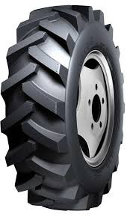

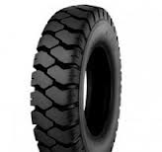 **CL619 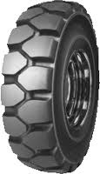 CL402**

